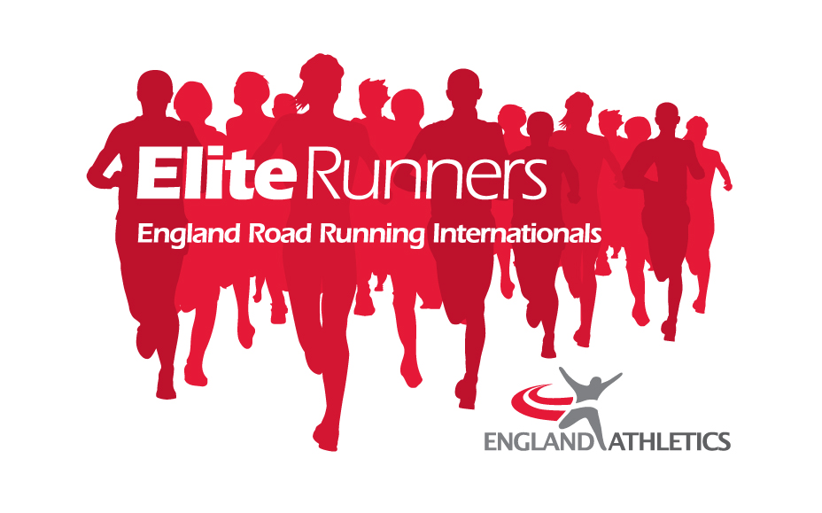

England Representative Opportunities in Road Running
Antrim Coast Half Marathon, 21 March, 2020
England Athletics value the importance of competitive road running opportunities for athletes seeking first time international experience as well as those looking to further develop themselves through international competition. We aim to both reward and acknowledge athletes meeting the selection criteria for the first time as well as providing opportunity for those athletes with the potential to challenge for future global championship teams, including the 2022 Commonwealth Games in Birmingham.
The Antrim Coast Half Marathon To date we have several prominent UK & IRE athletes in both men's and women's races already confirmed, with a view to breaking the Northern Ireland All-comers records of 72:58 for women and 62:22 for men, and have come up with a flat, fast course to hopefully support the objective ( Max. elevation 13 m, Min. elevation -11m, elevation gain 89m, loss 99m).

The course itself is a mix of racing through the town and also out the Antrim Coast (Home of Game of Thrones) with possibly the fastest finish to any road race in the UK. BBC NI will be covering the event on the day as well as Cool FM radio, so hopefully there will be a lot of crowd support and energy on the course for the runners.

https://athleticsni.org/Fixtures/Caterpillar-Antrim-Coast-Half-Marathon

Eligibility

To be considered for selection, athletes must satisfy the following:

- Be a registered athlete and be eligible to compete for England (i.e. full British passport holder).
- Have achieved a relevant England Athletics development standard within the qualification period.

Qualification Standards

Men | Event | Women
51:00 | 10 miles | 58:00
1:07:00 | Half Marathon | 1:17:00
2:23:00 | Marathon | 2:44:00

*Qualification performances must be achieved between 00:00 (GMT) 1 January 2019 & 24:00 (GMT) 16 February 2020 (GMT).

Selection Process & Criteria

- The team will be selected the week beginning 17th February, 2020
- Up to a maximum of four men and four women athletes may be selected.
- The Selection Panel will select athletes who meet the qualification standards, based on current form and fitness, head to heads and competition history up to and including midnight 16th February 2020
- Performances by athletes placing highly at any 2019 England Athletics Road Championships will also be given strong consideration in addition to point III criteria and meeting qualification standards.
- In exceptional circumstances only England Athletics reserve the right to select athletes without a current standard.
Appeals
There shall be no right of appeal to the selection of the England Team made by the Selection Panel. The provisions of the UK Athletics Selection and Nomination “Fast” Appeals Procedure” do not apply to the England team selections for the Granollers Half Marathon.

Additional Notes
Any selected athlete with doubts over their fitness in the lead up to the race may be required to evidence a fitness test. England Athletics reserve the right to deselect athletes who the selection panel feel are not fit or competitive enough in the final month before the event.
Athletes who withdraw themselves for reasons other than illness or injury may also be liable to cover the costs of their flights or a change of name to the ticket where there is the option to substitute.

Expressions of Interest
Please send expressions of interest to the National Endurance Lead Spencer Duval on sduval@englandathletics.org no later than midnight Sunday 16th February 2020

